CURRICULUM VITAE – Andrzej Okoń
Personal details
Name:  Date of birth:  Address:  Phone number:  E-mail address: | Andrzej Okoń  27-03-1981  93-172 Łódź, St. Łukasińskiego 4/261  667-758-866  andrzej.b.okon@gmail.com |  | 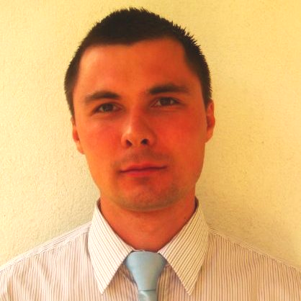
Objectives
Work on modern web application’s architecture in expert environment. Use best java technologies and approaches
Education
2010 – 2011 |  | Technical University of Lodz – Organization and Management  - Postgraduate: Projects Managements  - Master Thesis: Project management PRINCE2 methodology
2000 – 2005 |  | Technical University of Lodz – Technical Physics, Computer Sciences and Applied Mathematics (FTIMS)  - Specialization: Computer Networks and Telecommunication Systems  - Master Thesis: Design Patterns in J2EE, final study result: 5
2003 - 2003 |  | University of East Anglia in Norwich – Computer Science  - Socrates Erasmus scholarship, final results: A,A,A,B and Dean’s award
1996 – 2000 |  | 1st High School name of Nicolaus Copernicus in Lodz  - Mathematics and Physics, graduated with distinctions
Professional Experience
03.2017-Curent |  | Senior Java Developer / Tech Lead role,  Commerz Systems GmbH  - Creating prototype and architecture for future web application: java8, spring5, angular5, bootstrap4, rest, mongodb, websockets, jms, git, maven, intellij  - Adding functionalities to existing webapps  - Technical recruiting new team members
04.2009-02.2017 |  | IT Project Manager, Expert / IT Principal Specialist / IT Java Designer  Bank Pekao – Electronic Multi Channels Development Team  - 3 years of technical project management, team up to 10 people, in the role of Tech Lead and Project Manager  - 5 years of various web applications implementation, creating functional analysis and making solution architecture  - Cooperating with internal customers and project teams both in Lodz and Warsaw, working with suppliers  - Comprehensive knowledge of the whole life cycle of software development in banking sector  - Main technologies: Java, Spring, PL/SQL, CSH, WebSphere, Oracle
05.2005–03.2009 |  | Analyst Programmer / Senior Programmer / Programmer  Accenture Technology Solutions - Application Management Services Team  - Maintaining critical 24/7 web applications of bank Pekao S.A., available for millions customers  - Significant participation in strategic projects such as launching Brokerage House and merging with bank BPH  - Implementation new functionalities and bug fixes under time pressure  - Execution improvements in the monitoring of banking applications  - Main technologies: C++(corba), PL/SQL, CSH, BroadVision, Oracle
06.2004–08.2004 |  | Trainee, Xerox Poland  • Implementation document management application on Tomcat

CURRICULUM VITAE – Andrzej Okoń
Additional qualities and skills
Methodologies | Scrum, Prince2, PMBoK, ITIL
Technologies | Java, spring, springboot, rest, soap, jms, websockets, microservices with eureka, cxf, jpa, hibernate, mongodb, oracle, mysql, angular, bootstrap, jsp, jsf, c++(corba), xslt, java script, html, css, csh, pl/sql, junit, mockito
Principles | DDD, TDD, Clean Code
Applications | IntelliJ, Eclipse, JIRA, Confluence, Ms Project, Ms Enterprise Architect, jenkins, git, gerrit, svn, maven, ant, sonar
Languages | English: Work proficiency; German: Basic
Certifications and trainings
Certifications  Trainings | - 2011: PRINCE 2 Fundation, best group score  - 2006: TOEIC 790 points - Proficiency in English  - 2017: ITIL  - 2015: Agile Project Management: Professional Scrum Master / Modelowanie procesów biznesowych w BPMN 2.0 z wykorzystaniem Enterprise Architect / JIRA  - 2014: Enterprise Architect / Motywowanie pracowników / Delegowanie zadań  - 2013: ECDL Zarzadzanie Projektami / Szybko czy dobrze? Jak współpracować z biznesem / Szacowanie i wykonywanie zadań / Optymalizacja zapytań sql  - 2012: Optymalizacja i skalowanie aplikacji biznesowych / Techniki pracy z kodem / Create a secure web applications in Java / Enterprise Architect  - 2011: Create a Web application based on Spring and Hibernate / Independence and operational flexibility  - 2010: Programing in Java / Websphere server administration  - 2009: Coaching in Workplace  - 2008: Cross Cultural Communication  - 2007: Custom Application Design / Application Design Framework  - 2006: Technical Writing / Application Testing
Summary
Removes complexity, sees various solutions, focused on quality and clean code, agile, able to work independent or in TL role, understands team and business needs, still learning, likes to work with talented people and on application's architecture

Interests
Swimming, bike, skiing, sensational books

Wyrażam zgodę na przetwarzanie danych osobowych zawartych w mojej ofercie pracy dla potrzeb niezbędnych do realizacji procesu rekrutacji (podstawa prawna: Dz. U. Nr 133, poz. 883).

